**1] Write a java program which will generate the thread to display 10 terms of Fibonacci series and to display 1 to 10 in reverse order.**

**Code:**package threads;

class FibonacciThread extends Thread {

public void run() {

int num1 = 0, num2 = 1;

System.***out***.println("Fibonacci Series:");

System.***out***.print(num1 + " " + num2 + " ");

for (int i = 3; i <= 10; i++) {

int sum = num1 + num2;

System.***out***.print(sum + " ");

num1 = num2;

num2 = sum;

}}}

class ReverseThread extends Thread {

public void run() {

System.***out***.println("\nReverse Numbers:");

for (int i = 10; i >= 1; i--) {

System.***out***.print(i + " ");

}}}

public class Threads {

public static void main(String[] args) {

FibonacciThread fibThread = new FibonacciThread();

ReverseThread revThread = new ReverseThread();

fibThread.start();

try {

fibThread.join();

} catch (InterruptedException e) {

Thread.*currentThread*().interrupt();

}revThread.start();

}}

**Output:**

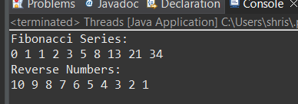

**2] Write a java program to Create thread and print the thread name and thread id.**

**Code:**

package threads;

class Thread2 extends Thread {

private int threadId;

public Thread2(String name, int threadId) {

super(name);

this.threadId = threadId;

}

public void run() {

System.***out***.println("Thread Name: " + getName() + " ID: " + threadId);

}

public static void main(String[] args) {

Thread2 t1 = new Thread2("First Thread", 21);

Thread2 t2 = new Thread2("Second Thread", 22);

t1.start();

t2.start();

}

}

**Output:**

